Usage Guide

Welcome!!!

To build your new Gazebo World,

1. Open MATLAB
2. Open the tree_generator.m script
3. Keep your DEM in the same location as the MATLAB Script

Using the script

The script allows you to change which DEM to use, how many trees to place, and what the separation between them should be.

1. Selecting the DEM

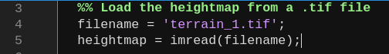

2. Choosing the number of trees to place and the bounds for the world

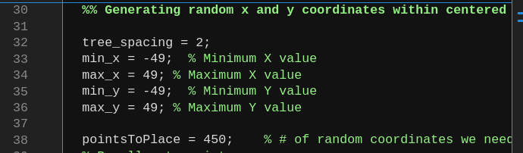
Example code shows a tree spacing of 2m, manually defined x and y bounds based on the terrain size,
and the number of trees, or points, to place. This is 450 here.

This code allows us to place 450 trees on an area of 100m x 100m.

3. Visualizing the output

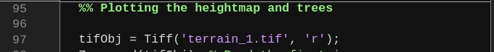
You will have to change the name of the terrain to your terrain here

4. Run the file

5. Output

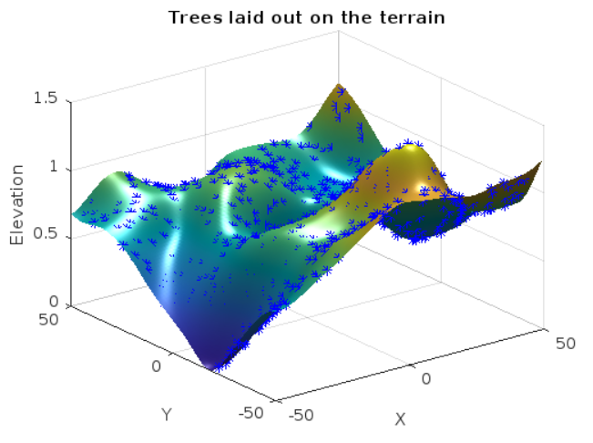
The trees are placed according to the elevation of the terrain, and a tree_positions.csv file is created. This csv file will be used by the accompanying ‘world_modifier.py’ script.

Using the world_modifier.py script

1. Navigate to the portion where

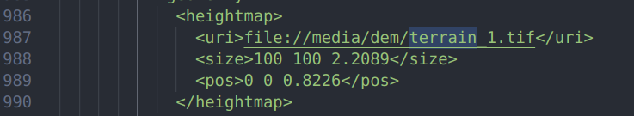

Change the name of the DEM to your DEM. Change the size to the size of your DEM. Leave the Z size value unchanged and contact Shameer to know what it should be. Your MATLAB script prints the total elevation on the command window. Put that elevation here.

2. Change the name and size of the DEM here too

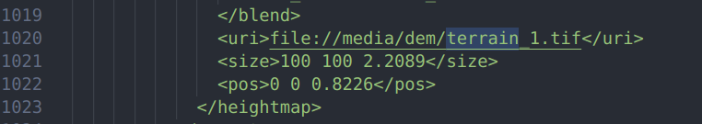
3. Run the python script. A file by the name of new.world will be created. This can be loaded into Gazebo by navigating to the directory where it is located, and running ‘gazebo new.world’

